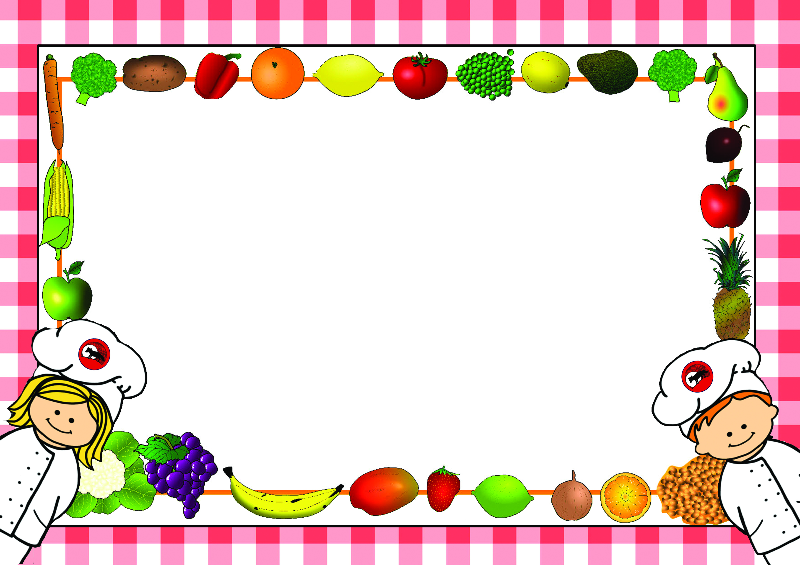

*Menus are correct at time of printing however menus may need to change occasionally
if products are unavailable or on ‘Themed Days’ which will be notified in advance*

Lunch Menus – Summer Term 1
2023-2024

Name of Child……………………………………………………………Class……………………………
□Please tick this box if you do not want your child to make any changes to the choices in the menu.

For office use:
Date received……………………… Returned to Parent………………………

Lunch Menu – Summer Term 1 - Week 1
Monday 8th April 2024

Week - | Monday | Tick | Tuesday | Tick | Wednesday | Tick | Thursday | Tick | Friday | Tick
Example | Sausage
Main Course | Chicken Korma |  | Homemade Burgers |  | Roast Chicken |  | Pasta with Homemade Tomato Sauce |  | Fish Fingers
Vegetarian  Option | Vegetable Korma |  | Veggie Burger |  | Quorn Sausage |  |  |  | Veggie Fingers
Light Bite | Beans on Toast |  | Cheese & Onion Slice |  | Tomato Soup with Crusty Bread |  | Pasta with Cheese |  | Fish Finger Sandwich
Jacket Potato  (Please circle topping choice) | Cheese, Beans  Tuna |  | Cheese, Beans  Tuna |  | Cheese, Beans  Tuna |  | Cheese, Beans  Tuna |  | Cheese, Beans  Tuna
Sandwich  Please tick your choice of sandwich | Ham |  | Ham |  | Ham |  | Ham |  | Ham
Sandwich  Please tick your choice of sandwich | Cheese |  | Cheese |  | Cheese |  | Cheese |  | Cheese
Sandwich  Please tick your choice of sandwich | Egg |  | Egg |  | Egg |  | Egg |  | Egg
Sandwich  Please tick your choice of sandwich | Tuna |  | Tuna |  | Tuna |  | Tuna |  | Tuna
Carbohydrate | Savoury Rice |  | Oven Fries |  | Mashed Potato  Yorkshire |  | Garlic Slice  Pasta |  | Oven Chips
Vegetables/  Accompaniments | Naan |  | Bean’s |  | Diced Carrots  Green Beans |  | Mixed Green Salad |  | Peas  Beans
Desserts | Fruit Smoothies |  | Flapjack |  | Jam Roly Poly & Custard |  | Apple, Pear & Chocolate Crumble with Custard |  | Chocolate Ice Cream Roll
All meals are cooked from scratch on a daily basis. Carbohydrates, Vegetables and Desserts can be chosen on the day so no need to pre-order. Please indicate by ticking what your child would like for Main Course as shown in the example and return to school. Meals are at a cost of £2.10 a day and can be paid on Parent-Pay or in cash or cheque to school. No payment is required from Reception or KS.1

Lunch Menu – Summer Term 1 - Week 2
Monday 15th April 2024

Week - | Monday | Tick | Tuesday | Tick | Wednesday | Tick | Thursday | Tick | Friday | Tick
Main Course | Spaghetti Bolognaise |  | Fish Pie |  | Sausage |  | BBQ Chicken |  | Cheese & Tomato Pizza
Vegetarian  Option | Vegetable Bolognaise |  | Macaroni Cheese |  | Veggie Sausage |  | BBQ Vegetables
Light Bite | Cheese Panini |  | Beans on Toast |  | Sausage Sandwich |  | Cheese on Toast |  | Meat Ravioli & Cheese
Jacket Potato  (Please circle topping choice) | Cheese, Beans  Tuna |  | Cheese, Beans  Tuna |  | Cheese, Beans  Tuna |  | Cheese, Beans  Tuna |  | Cheese, Beans  Tuna
Sandwich  Please tick your choice of sandwich | Ham |  | Ham |  | Ham |  | Ham |  | Ham
Sandwich  Please tick your choice of sandwich | Cheese |  | Cheese |  | Cheese |  | Cheese |  | Cheese
Sandwich  Please tick your choice of sandwich | Egg |  | Egg |  | Egg |  | Egg |  | Egg
Sandwich  Please tick your choice of sandwich | Tuna |  | Tuna |  | Tuna |  | Tuna |  | Tuna
Carbohydrate | Pasta |  | Mashed Potato Topping |  | Mashed Potato  Yorkshire Pudding |  | Savoury Rice |  | Potato Wedges
Vegetables/  Accompaniments | Vegetable Fingers |  | Peas |  | Broccoli  Carrots |  | Tortilla Wrap |  | Sweetcorn  Beans
Desserts | Fruit Salad with Ice Cream  Cheese & Crackers |  | Iced Ginger Sponge |  | Chocolate Sponge & Chocolate Sauce |  | Treacle Roly Poly |  | Chocolate Krispies Nest
All meals are cooked from scratch on a daily basis. Carbohydrates, Vegetables and Desserts can be chosen on the day so no need to pre-order. Please indicate by ticking what your child would like for Main Course as shown in the example and return to school. Meals are at a cost of £2.10 a day and can be paid on Parent-Pay or in cash or cheque to school. No payment is required from Reception or KS.1

Lunch Menu – Summer Term 1 - Week 3
Monday 22nd April 2024

Week - | Monday | Tick | Tuesday | Tick | Wednesday | Tick | Thursday | Tick | Friday | Tick
Main Course | Chicken & Sweetcorn Pasta Bake in White Sauce |  | Fish Cakes |  | Gammon |  | Chicken Fajitas |  | Hot Dogs
Vegetarian  Option | Cheese & Pasta Bake |  | Cheese & Tomato Roll |  | Quorn in Gravy |  | Vegetable Fajitas |  | Veggie Dogs
Light Bite | Beans on Toast |  | Cheese Panini |  | Potato & Leek Soup with Crusty Bread |  | Spaghetti Hoops on Toast |  | Cheese & Savoury Wrap
Jacket Potato  (Please circle topping choice) | Cheese, Beans  Tuna |  | Cheese, Beans  Tuna |  | Cheese, Beans  Tuna |  | Cheese, Beans  Tuna |  | Cheese, Beans  Tuna
Sandwich  Please tick your choice of sandwich | Ham |  | Ham |  | Ham |  | Ham |  | Ham
Sandwich  Please tick your choice of sandwich | Cheese |  | Cheese |  | Cheese |  | Cheese |  | Cheese
Sandwich  Please tick your choice of sandwich | Egg |  | Egg |  | Egg |  | Egg |  | Egg
Sandwich  Please tick your choice of sandwich | Tuna |  | Tuna |  | Tuna |  | Tuna |  | Tuna
Carbohydrate | Crusty Bread |  | Mashed Potato |  | Roast Potatoes  Yorkshire Pudding |  | Potato Wedges |  | Oven Chips
Vegetables/  Accompaniments | Green Beans |  | Peas |  | Carrots  Sweetcorn |  | Vegetable Fingers |  | Peas  Beans
Desserts | Chocolate Brownies |  | Treacle Dumpling with Custard |  | Milk Pudding with Jam/Sultanas |  | Coconut Cookie |  | Fruit Jelly
All meals are cooked from scratch on a daily basis. Carbohydrates, Vegetables and Desserts can be chosen on the day so no need to pre-order. Please indicate by ticking what your child would like for Main Course as shown in the example and return to school. Meals are at a cost of £2.10 a day and can be paid on Parent-Pay or in cash or cheque to school. No payment is required from Reception or KS.1

Lunch Menu – Summer Term 1 - Week 4
Monday 29th April 2024

Week - | Monday | Tick | Tuesday | Tick | Wednesday | Tick | Thursday | Tick | Friday | Tick
Main Course | Chicken Korma |  | Homemade Burgers |  | Roast Chicken |  | Pasta with Homemade Tomato Sauce |  | Fish Fingers
Vegetarian  Option | Vegetable Korma |  | Veggie Burger |  | Quorn Sausage |  |  |  | Veggie Fingers
Light Bite | Beans on Toast |  | Cheese & Onion Slice |  | Tomato Soup with Crusty Bread |  | Pasta with Cheese |  | Fish Finger Sandwich
Jacket Potato  (Please circle topping choice) | Cheese, Beans  Tuna |  | Cheese, Beans  Tuna |  | Cheese, Beans  Tuna |  | Cheese, Beans  Tuna |  | Cheese, Beans  Tuna
Sandwich  Please tick your choice of sandwich | Ham |  | Ham |  | Ham |  | Ham |  | Ham
Sandwich  Please tick your choice of sandwich | Cheese |  | Cheese |  | Cheese |  | Cheese |  | Cheese
Sandwich  Please tick your choice of sandwich | Egg |  | Egg |  | Egg |  | Egg |  | Egg
Sandwich  Please tick your choice of sandwich | Tuna |  | Tuna |  | Tuna |  | Tuna |  | Tuna
Carbohydrate | Savoury Rice |  | Oven Fries |  | Mashed Potato  Yorkshire |  | Garlic Slice  Pasta |  | Oven Chips
Vegetables/  Accompaniments | Naan |  | Bean’s |  | Diced Carrots  Green Beans |  | Mixed Green Salad |  | Peas  Beans
Desserts | Fruit Smoothies |  | Flapjack |  | Jam Roly Poly & Custard |  | Apple, Pear & Chocolate Crumble with Custard |  | Chocolate Ice Cream Roll
All meals are cooked from scratch on a daily basis. Carbohydrates, Vegetables and Desserts can be chosen on the day so no need to pre-order. Please indicate by ticking what your child would like for Main Course as shown in the example and return to school. Meals are at a cost of £2.10 a day and can be paid on Parent-Pay or in cash or cheque to school. No payment is required from Reception or KS.1

Lunch Menu – Summer Term 1 - Week 5
Monday 6th May 2024

Week - | Monday | Tick | Tuesday | Tick | Wednesday | Tick | Thursday | Tick | Friday | Tick
 | BANK HOLIDAY
Main Course |  |  | Fish Pie |  | Sausage |  | BBQ Chicken |  | Cheese & Tomato Pizza
Vegetarian  Option |  |  | Macaroni Cheese |  | Veggie Sausage |  | BBQ Vegetables
Light Bite |  |  | Beans on Toast |  | Sausage Sandwich |  | Cheese on Toast |  | Meat Ravioli & Cheese
Jacket Potato  (Please circle topping choice) |  |  | Cheese, Beans  Tuna |  | Cheese, Beans  Tuna |  | Cheese, Beans  Tuna |  | Cheese, Beans  Tuna
Sandwich  Please tick your choice of sandwich |  |  | Ham |  | Ham |  | Ham |  | Ham
Sandwich  Please tick your choice of sandwich |  |  | Cheese |  | Cheese |  | Cheese |  | Cheese
Sandwich  Please tick your choice of sandwich |  |  | Egg |  | Egg |  | Egg |  | Egg
Sandwich  Please tick your choice of sandwich |  |  | Tuna |  | Tuna |  | Tuna |  | Tuna
Carbohydrate |  |  | Mashed Potato Topping |  | Mashed Potato  Yorkshire Pudding |  | Savoury Rice |  | Potato Wedges
Vegetables/  Accompaniments |  |  | Peas |  | Broccoli  Carrots |  | Tortilla Wrap |  | Sweetcorn  Beans
Desserts |  |  | Iced Ginger Sponge |  | Chocolate Sponge & Chocolate Sauce |  | Treacle Roly Poly |  | Chocolate Krispies Nest
All meals are cooked from scratch on a daily basis. Carbohydrates, Vegetables and Desserts can be chosen on the day so no need to pre-order. Please indicate by ticking what your child would like for Main Course as shown in the example and return to school. Meals are at a cost of £2.10 a day and can be paid on Parent-Pay or in cash or cheque to school. No payment is required from Reception or KS.1

Lunch Menu – Summer Term 1 - Week 6
Monday 13th May 2024

Week - | Monday | Tick | Tuesday | Tick | Wednesday | Tick | Thursday | Tick | Friday | Tick
Main Course | Chicken & Sweetcorn Pasta Bake in White Sauce |  | Fish Cakes |  | Gammon |  | Chicken Fajitas |  | Hot Dogs
Vegetarian  Option | Cheese & Pasta Bake |  | Cheese & Tomato Roll |  | Quorn in Gravy |  | Vegetable Fajitas |  | Veggie Dogs
Light Bite | Beans on Toast |  | Cheese Panini |  | Potato & Leek Soup with Crusty Bread |  | Spaghetti Hoops on Toast |  | Cheese & Savoury Wrap
Jacket Potato  (Please circle topping choice) | Cheese, Beans  Tuna |  | Cheese, Beans  Tuna |  | Cheese, Beans  Tuna |  | Cheese, Beans  Tuna |  | Cheese, Beans  Tuna
Sandwich  Please tick your choice of sandwich | Ham |  | Ham |  | Ham |  | Ham |  | Ham
Sandwich  Please tick your choice of sandwich | Cheese |  | Cheese |  | Cheese |  | Cheese |  | Cheese
Sandwich  Please tick your choice of sandwich | Egg |  | Egg |  | Egg |  | Egg |  | Egg
Sandwich  Please tick your choice of sandwich | Tuna |  | Tuna |  | Tuna |  | Tuna |  | Tuna
Carbohydrate | Crusty Bread |  | Mashed Potato |  | Roast Potatoes  Yorkshire Pudding |  | Potato Wedges |  | Oven Chips
Vegetables/  Accompaniments | Green Beans |  | Peas |  | Carrots  Sweetcorn |  | Vegetable Fingers |  | Peas  Beans
Desserts | Chocolate Brownies |  | Treacle Dumpling with Custard |  | Milk Pudding with Jam/Sultanas |  | Coconut Cookie |  | Fruit Jelly
All meals are cooked from scratch on a daily basis. Carbohydrates, Vegetables and Desserts can be chosen on the day so no need to pre-order. Please indicate by ticking what your child would like for Main Course as shown in the example and return to school. Meals are at a cost of £2.10 a day and can be paid on Parent-Pay or in cash or cheque to school. No payment is required from Reception or KS.1

Lunch Menu – Summer Term 1 - Week 7
Monday 20th May 2024

Week - | Monday | Tick | Tuesday | Tick | Wednesday | Tick | Thursday | Tick | Friday | Tick
Main Course | Chicken Korma |  | Homemade Burgers |  | Roast Chicken |  | Pasta with Homemade Tomato Sauce |  | Fish Fingers
Vegetarian  Option | Vegetable Korma |  | Veggie Burger |  | Quorn Sausage |  |  |  | Veggie Fingers
Light Bite | Beans on Toast |  | Cheese & Onion Slice |  | Tomato Soup with Crusty Bread |  | Pasta with Cheese |  | Fish Finger Sandwich
Jacket Potato  (Please circle topping choice) | Cheese, Beans  Tuna |  | Cheese, Beans  Tuna |  | Cheese, Beans  Tuna |  | Cheese, Beans  Tuna |  | Cheese, Beans  Tuna
Sandwich  Please tick your choice of sandwich | Ham |  | Ham |  | Ham |  | Ham |  | Ham
Sandwich  Please tick your choice of sandwich | Cheese |  | Cheese |  | Cheese |  | Cheese |  | Cheese
Sandwich  Please tick your choice of sandwich | Egg |  | Egg |  | Egg |  | Egg |  | Egg
Sandwich  Please tick your choice of sandwich | Tuna |  | Tuna |  | Tuna |  | Tuna |  | Tuna
Carbohydrate | Savoury Rice |  | Oven Fries |  | Mashed Potato  Yorkshire |  | Garlic Slice  Pasta |  | Oven Chips
Vegetables/  Accompaniments | Naan |  | Bean’s |  | Diced Carrots  Green Beans |  | Mixed Green Salad |  | Peas  Beans
Desserts | Fruit Smoothies |  | Flapjack |  | Jam Roly Poly & Custard |  | Apple, Pear & Chocolate Crumble with Custard |  | Chocolate Ice Cream Roll
All meals are cooked from scratch on a daily basis. Carbohydrates, Vegetables and Desserts can be chosen on the day so no need to pre-order. Please indicate by ticking what your child would like for Main Course as shown in the example and return to school. Meals are at a cost of £2.10 a day and can be paid on Parent-Pay or in cash or cheque to school. No payment is required from Reception or KS.1

