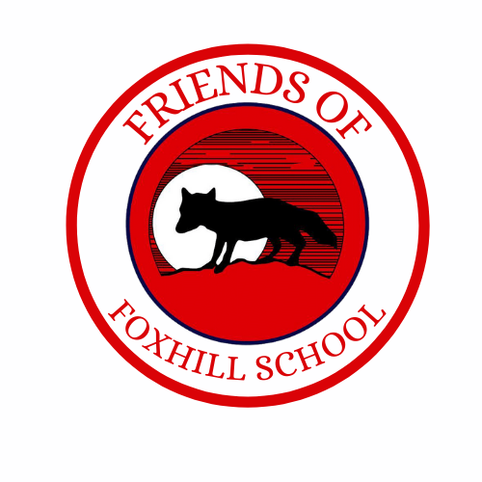

28th April 2025

Dear Parents/Carers,

Friends of Foxhill would like to help the children celebrate Father’s Day on Sunday 15th June with a gift to their special someone.

If they would like to buy a gift for that special someone for Father’s Day, it will cost **£5.00 per gift** (payable on ParentPay).

This years gift is BBQ themed! We are looking to supply you with BBQ Sauce, Spices/Seasonings, Skewers & BBQ crisps.

If you would like to order a gift, please return the slip & payment no later than **Friday 23rd May 2025.** Gifts will be handed out on Friday 13th June.

To place your pre-order, please fill out the attached form and return it to the office or email [fundraisers@foxhill.bradford.sch.uk](mailto:fundraisers@foxhill.bradford.sch.uk) by May 23rd. Payments can be made in cash or parentpay.

Thank you for your continued support.

Kind Regards,

Friends of Foxhill

[fundraisers@foxhill.bradford.sch.uk](mailto:fundraisers@foxhill.bradford.sch.uk)

******************************************************************************************

My child/children would like to purchase a Father’s Day gift.

Child’s Name ………………………………………………………………Class…………………………………….

Amount of gifts ………………………………………………………………