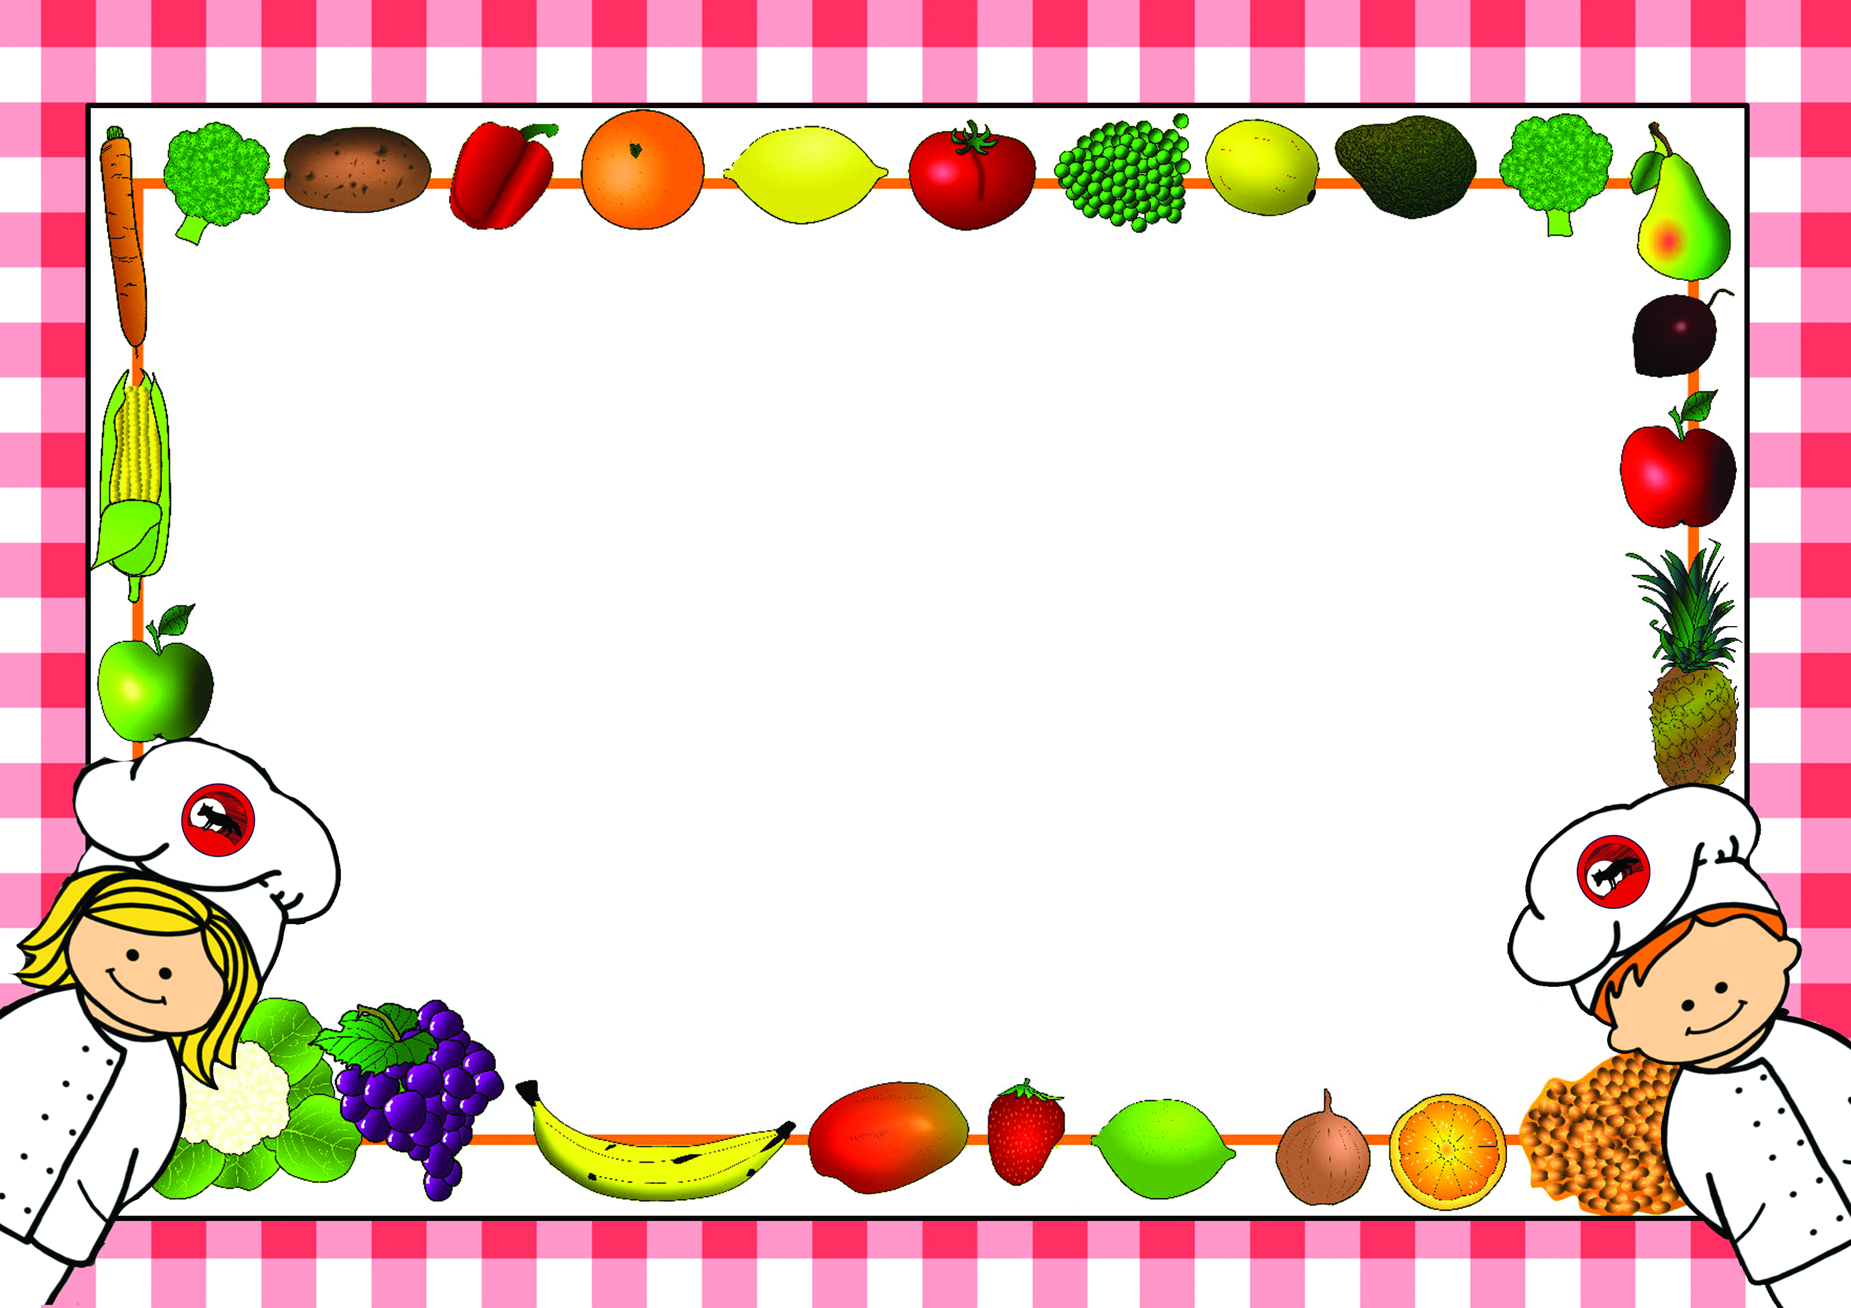

*Menus are correct at time of printing however menus may need to change occasionally
if products are unavailable or on ‘Themed Days’ which will be notified in advance*

Lunch Menus – Summer Term 2
2024-2025

Name of Child……………………………………………………………Class……………………………
□Please tick this box if you do not want your child to make any changes to the choices in the menu.

For office use:
Date received……………………… Returned to Parent………………………

Lunch Menu – Summer Term 2 - Week 1
Monday 9th June 2025

Week - | Monday | Tick | Tuesday | Tick | Wednesday | Tick | Thursday | Tick | Friday | Tick
Example | Sausage
Main Course | Brunch |  | Chicken Pie |  | Roast Chicken |  | Spaghetti Bolognaise |  | Fish Fingers
Vegetarian  Option | Vegetarian Brunch |  | Cheese & Onion Pie |  | Vegetable Bake |  | Vegetarian Bolognaise |  | Veggie Fingers
Light Bite | Beans on Toast |  | Tomato Soup |  | Chicken Salad |  | Pasta with Cheese |  | Fish Finger Sandwich
Jacket Potato  (Please circle topping choice) | Cheese, Beans  Tuna |  | Cheese, Beans  Tuna |  | Cheese, Beans  Tuna |  | Cheese, Beans  Tuna |  | Cheese, Beans  Tuna
Sandwich  Please tick your choice of sandwich | Ham |  | Ham |  | Ham |  | Ham |  | Ham
Sandwich  Please tick your choice of sandwich | Cheese |  | Cheese |  | Cheese |  | Cheese |  | Cheese
Sandwich  Please tick your choice of sandwich | Egg |  | Egg |  | Egg |  | Egg |  | Egg
Sandwich  Please tick your choice of sandwich | Tuna |  | Tuna |  | Tuna |  | Tuna |  | Tuna
Carbohydrate | Toast  Hashbrowns |  | Sautéed Potatoes |  | Yorkshire Pudding  Mashed Potato |  | Pasta |  | Oven Chips
Vegetables/  Accompaniments | Scrambled Egg |  | Diced Carrots |  | Sweetcorn  Green Beans |  | Italian Salad |  | Peas  Beans
Desserts | Chocolate Brownie |  | Coconut Cookie |  | Flapjack |  | Treacle Sponge with Custard |  | Chocolate Mousse
All meals are cooked from scratch on a daily basis. Carbohydrates, Vegetables and Desserts can be chosen on the day so no need to pre-order. Please indicate by ticking what your child would like for Main Course as shown in the example and return to school. Meals are at a cost of £2.35 a day and can be paid on Parent-Pay or in cash or cheque to school. No payment is required from Reception or KS.1

Lunch Menu – Summer Term 2 - Week 2
Monday 16th June 2025

Week - | Monday | Tick | Tuesday | Tick | Wednesday | Tick | Thursday | Tick | Friday | Tick
Main Course | Pasta with Homemade Tomato & Vegetable Sauce |  | Fish Nuggets |  | Toad in the Hole |  | Chicken Korma |  | Cheese & Tomato Pizza
Vegetarian  Option |  |  | Veggie Nuggets |  | Vegetarian Toad in the Hole |  | Vegetable Korma
Light Bite | Pasta with Cheese |  | Beans on Toast |  | Sausage Sandwich |  | Cheese Panini |  | Meat Ravioli
Jacket Potato  (Please circle topping choice) | Cheese, Beans  Tuna |  | Cheese, Beans  Tuna |  | Cheese, Beans  Tuna |  | Cheese, Beans  Tuna |  | Cheese, Beans  Tuna
Sandwich  Please tick your choice of sandwich | Ham |  | Ham |  | Ham |  | Ham |  | Ham
Sandwich  Please tick your choice of sandwich | Cheese |  | Cheese |  | Cheese |  | Cheese |  | Cheese
Sandwich  Please tick your choice of sandwich | Egg |  | Egg |  | Egg |  | Egg |  | Egg
Sandwich  Please tick your choice of sandwich | Tuna |  | Tuna |  | Tuna |  | Tuna |  | Tuna
Carbohydrate | Garlic Bread Finger |  | Boiled Potatoes |  | Yorkshire Pudding  Mashed Potato |  | Naan |  | Potato Wedges
Vegetables/  Accompaniments | Mixed Salad |  | Peas |  | Diced Carrots  Peas |  | Savoury Rice |  | Sweetcorn  Beans
Desserts | Iced Raspberry Slice |  | Chocolate Sponge with Chocolate Sauce |  | Carrot Cake with Toffee Icing |  | Fruit & Ice Cream |  | Jelly
All meals are cooked from scratch on a daily basis. Carbohydrates, Vegetables and Desserts can be chosen on the day so no need to pre-order. Please indicate by ticking what your child would like for Main Course as shown in the example and return to school. Meals are at a cost of £2.35 a day and can be paid on Parent-Pay or in cash or cheque to school. No payment is required from Reception or KS.1

Lunch Menu – Summer Term 2 - Week 3
Monday 23rd June 2025

Week - | Monday | Tick | Tuesday | Tick | Wednesday | Tick | Thursday | Tick | Friday | Tick
Main Course | McFoxy Chicken Burger |  | Corned Beef & Potato Slice |  | Roast Gammon |  | Katsu Chicken |  | Hot Dogs
Vegetarian  Option | Vegetarian Burger |  | Cheese & Onion Quiche |  | Cauliflower & Broccoli Bake |  | Veggie Katsu |  | Veggie Dogs
Light Bite | Cheese on Toast |  | Pasta with Cheese |  | Falafel with Green Salad & Hummus |  | Beans on Toast |  | Cheese, Onion, Carrot & Mayo Wrap
Jacket Potato  (Please circle topping choice) | Cheese, Beans  Tuna |  | Cheese, Beans  Tuna |  | Cheese, Beans  Tuna |  | Cheese, Beans  Tuna |  | Cheese, Beans  Tuna
Sandwich  Please tick your choice of sandwich | Ham |  | Ham |  | Ham |  | Ham |  | Ham
Sandwich  Please tick your choice of sandwich | Cheese |  | Cheese |  | Cheese |  | Cheese |  | Cheese
Sandwich  Please tick your choice of sandwich | Egg |  | Egg |  | Egg |  | Egg |  | Egg
Sandwich  Please tick your choice of sandwich | Tuna |  | Tuna |  | Tuna |  | Tuna |  | Tuna
Carbohydrate | Potato Wedges  Burger Bun |  | Mashed Potatoes |  | Roast Potatoes  Yorkshire Pudding |  | Rice |  | Oven Chips
Vegetables/  Accompaniments | Mixed Salad  Coleslaw |  | Peas  Beans |  | Carrots  Broccoli |  | Finger Veg |  | Peas
Desserts | Mixed Berries with Natural Yoghurt & Honey |  | Chocolate Fudge Cake |  | Apple Crumble with Custard |  | Rice Pudding |  | Ice Cream Roll
All meals are cooked from scratch on a daily basis. Carbohydrates, Vegetables and Desserts can be chosen on the day so no need to pre-order. Please indicate by ticking what your child would like for Main Course as shown in the example and return to school. Meals are at a cost of £2.35 a day and can be paid on Parent-Pay or in cash or cheque to school. No payment is required from Reception or KS.1

Lunch Menu – Summer Term 2 - Week 4
Monday 30th June 2025

Week - | Monday | Tick | Tuesday | Tick | Wednesday | Tick | Thursday | Tick | Friday | Tick
CONCERT REHEARSAL DAY –
Whole School Picnic
(Please select sandwich choice)
Main Course |  |  | Chicken Pie |  | Roast Chicken |  | Spaghetti Bolognaise |  | Fish Fingers
Vegetarian  Option |  |  | Cheese & Onion Pie |  | Vegetable Bake |  | Vegetarian Bolognaise |  | Veggie Fingers
Light Bite |  |  | Tomato Soup |  | Chicken Salad |  | Pasta with Cheese |  | Fish Finger Sandwich
Jacket Potato  (Please circle topping choice) |  |  | Cheese, Beans  Tuna |  | Cheese, Beans  Tuna |  | Cheese, Beans  Tuna |  | Cheese, Beans  Tuna
Sandwich  Please tick your choice of sandwich | Ham |  | Ham |  | Ham |  | Ham |  | Ham
Sandwich  Please tick your choice of sandwich | Cheese |  | Cheese |  | Cheese |  | Cheese |  | Cheese
Sandwich  Please tick your choice of sandwich | Egg |  | Egg |  | Egg |  | Egg |  | Egg
Sandwich  Please tick your choice of sandwich | Tuna |  | Tuna |  | Tuna |  | Tuna |  | Tuna
Carbohydrate |  |  | Sautéed Potatoes |  | Yorkshire Pudding  Mashed Potato |  | Pasta |  | Oven Chips
Vegetables/  Accompaniments |  |  | Diced Carrots |  | Sweetcorn  Green Beans |  | Italian Salad |  | Peas  Beans
Desserts |  |  | Coconut Cookie |  | Flapjack |  | Treacle Sponge with Custard |  | Chocolate Mousse

All meals are cooked from scratch on a daily basis. Carbohydrates, Vegetables and Desserts can be chosen on the day so no need to pre-order. Please indicate by ticking what your child would like for Main Course as shown in the example and return to school. Meals are at a cost of £2.35 a day and can be paid on Parent-Pay or in cash or cheque to school. No payment is required from Reception or KS.1

Lunch Menu – Summer Term 2 - Week 5
Monday 7th July 2025

Week - | Monday | Tick | Tuesday | Tick | Wednesday | Tick | Thursday | Tick | Friday | Tick
Main Course | Pasta with Homemade Tomato & Vegetable Sauce |  | Fish Nuggets |  | Toad in the Hole |  | Chicken Korma |  | Cheese & Tomato Pizza
Vegetarian  Option |  |  | Veggie Nuggets |  | Vegetarian Toad in the Hole |  | Vegetable Korma
Light Bite | Pasta with Cheese |  | Beans on Toast |  | Sausage Sandwich |  | Cheese Panini |  | Meat Ravioli
Jacket Potato  (Please circle topping choice) | Cheese, Beans  Tuna |  | Cheese, Beans  Tuna |  | Cheese, Beans  Tuna |  | Cheese, Beans  Tuna |  | Cheese, Beans  Tuna
Sandwich  Please tick your choice of sandwich | Ham |  | Ham |  | Ham |  | Ham |  | Ham
Sandwich  Please tick your choice of sandwich | Cheese |  | Cheese |  | Cheese |  | Cheese |  | Cheese
Sandwich  Please tick your choice of sandwich | Egg |  | Egg |  | Egg |  | Egg |  | Egg
Sandwich  Please tick your choice of sandwich | Tuna |  | Tuna |  | Tuna |  | Tuna |  | Tuna
Carbohydrate | Garlic Bread Finger |  | Boiled Potatoes |  | Yorkshire Pudding  Mashed Potato |  | Naan |  | Potato Wedges
Vegetables/  Accompaniments | Mixed Salad |  | Peas |  | Diced Carrots  Peas |  | Savoury Rice |  | Sweetcorn  Beans
Desserts | Iced Raspberry Slice |  | Chocolate Sponge with Chocolate Sauce |  | Carrot Cake with Toffee Icing |  | Fruit & Ice Cream |  | Jelly
All meals are cooked from scratch on a daily basis. Carbohydrates, Vegetables and Desserts can be chosen on the day so no need to pre-order. Please indicate by ticking what your child would like for Main Course as shown in the example and return to school. Meals are at a cost of £2.35 a day and can be paid on Parent-Pay or in cash or cheque to school. No payment is required from Reception or KS.1

Lunch Menu – Summer Term 2 - Week 6
Monday 14th July 2025

Week - | Monday | Tick | Tuesday | Tick | Wednesday | Tick | Thursday | Tick | Friday | Tick
Main Course | McFoxy Chicken Burger |  | Corned Beef & Potato Slice |  | Roast Gammon |  | Katsu Chicken |  | Hot Dogs
Vegetarian  Option | Vegetarian Burger |  | Cheese & Onion Quiche |  | Cauliflower & Broccoli Bake |  | Veggie Katsu |  | Veggie Dogs
Light Bite | Cheese on Toast |  | Pasta with Cheese |  | Falafel with Green Salad & Hummus |  | Beans on Toast |  | Cheese, Onion, Carrot & Mayo Wrap
Jacket Potato  (Please circle topping choice) | Cheese, Beans  Tuna |  | Cheese, Beans  Tuna |  | Cheese, Beans  Tuna |  | Cheese, Beans  Tuna |  | Cheese, Beans  Tuna
Sandwich  Please tick your choice of sandwich | Ham |  | Ham |  | Ham |  | Ham |  | Ham
Sandwich  Please tick your choice of sandwich | Cheese |  | Cheese |  | Cheese |  | Cheese |  | Cheese
Sandwich  Please tick your choice of sandwich | Egg |  | Egg |  | Egg |  | Egg |  | Egg
Sandwich  Please tick your choice of sandwich | Tuna |  | Tuna |  | Tuna |  | Tuna |  | Tuna
Carbohydrate | Potato Wedges  Burger Bun |  | Mashed Potatoes |  | Roast Potatoes  Yorkshire Pudding |  | Rice |  | Oven Chips
Vegetables/  Accompaniments | Mixed Salad  Coleslaw |  | Peas  Beans |  | Carrots  Broccoli |  | Finger Veg |  | Peas
Desserts | Mixed Berries with Natural Yoghurt & Honey |  | Chocolate Fudge Cake |  | Apple Crumble with Custard |  | Rice Pudding |  | Ice Cream Roll
All meals are cooked from scratch on a daily basis. Carbohydrates, Vegetables and Desserts can be chosen on the day so no need to pre-order. Please indicate by ticking what your child would like for Main Course as shown in the example and return to school. Meals are at a cost of £2.35 a day and can be paid on Parent-Pay or in cash or cheque to school. No payment is required from Reception or KS.1

Lunch Menu – Summer Term 2 - Week 7
Monday 21st July 2025

Week - | Monday | Tick | Tuesday | Tick | Wednesday | Tick | Thursday | Tick | Friday | Tick
FOXHILL FUN DAY –
Whole School Picnic
(Please select sandwich choice)
Main Course | Brunch |  |  |  | Fish Fingers
Vegetarian  Option | Vegetarian Brunch |  |  |  | Veggie Fingers
Light Bite | Beans on Toast |  |  |  | Fish Finger Sandwiches
Jacket Potato  (Please circle topping choice) | Cheese, Beans  Tuna |  |  |  | Cheese, Beans  Tuna
Sandwich  Please tick your choice of sandwich | Ham |  | Ham |  | Ham
Sandwich  Please tick your choice of sandwich | Cheese |  | Cheese |  | Cheese
Sandwich  Please tick your choice of sandwich | Egg |  | Egg |  | Egg
Sandwich  Please tick your choice of sandwich | Tuna |  | Tuna |  | Tuna
Carbohydrate | Toast  Hashbrowns |  |  |  | Oven Chips
Vegetables/  Accompaniments | Scrambled Egg |  |  |  | Peas
Desserts | Chocolate Brownie |  |  |  | Flapjack
All meals are cooked from scratch on a daily basis. Carbohydrates, Vegetables and Desserts can be chosen on the day so no need to pre-order. Please indicate by ticking what your child would like for Main Course as shown in the example and return to school. Meals are at a cost of £2.35 a day and can be paid on Parent-Pay or in cash or cheque to school. No payment is required from Reception or KS.1

