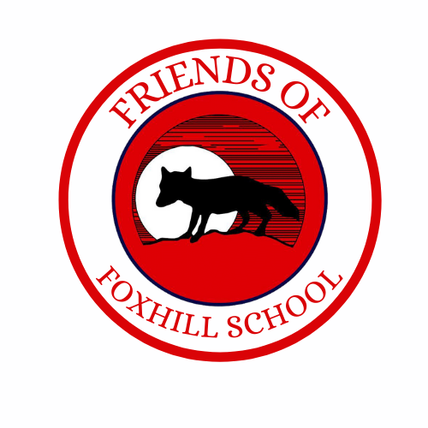



12th May 2026

Dear Parents/Carers,
The Friends of Foxhill PTA are delighted to offer a selection of Father’s Day gifts this year, available for just £5 each.
Children can choose from:
- A box of homemade vanilla fudge
- A box of brownies
- A pick-a-mix sweet box

Please note:
- The homemade vanilla fudge is gluten free and egg free.
- If you have any dietary requirements, please email us and we will do our best to accommodate them.

Please indicate below which gift/s you would like to order. All order forms and payments must be returned by Monday 8th June. Gifts will be sent home with children on Friday 19th June.

If you have any questions or dietary requirements, please contact us at:
fundraisers@foxhillprimaryschool.co.uk

Thank you for your continued support.

Friends of Foxhill PTA
……………………………………………………………………………………………………………………………………………………………………………………….
FATHER’S DAY GIFT ORDER FORM
Child’s Name/s………………………………………………………………………………………………………………………………….Class…………………
My child/children would like to purchase a Father’s Day gift:
Number of gifts……………………………………

Please tick your chosen gift(s):
☐ A box of homemade vanilla fudge
☐ A box of brownies
☐ A pick-a-mix sweet box

